Git Procedures for eChronos Contributors

Setup Git (for Windows)

Get Familiar with Git Concepts

Get Familiar with Bash-Style Commands & Navigation (used for doing Git stuff)

Get Familiar with Actual Git Commands

Checking Status of Local vs. Remote
Note about checking status before fetching: The 'status' command won't display remote changes if 'fetch' isn't used first
Here's an Example:
Status before fetch:
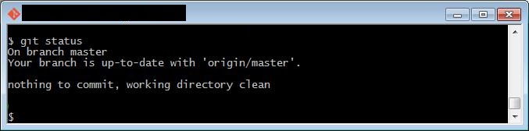
Fetching:
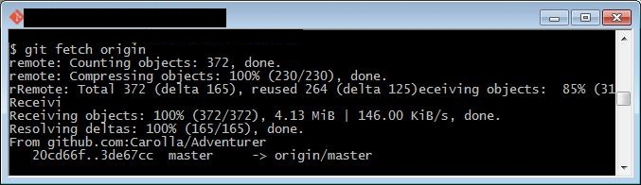
Status after fetch:
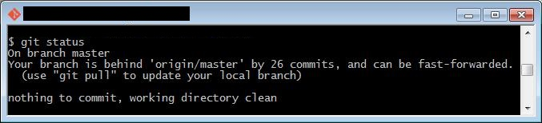
Note the difference using 'log':
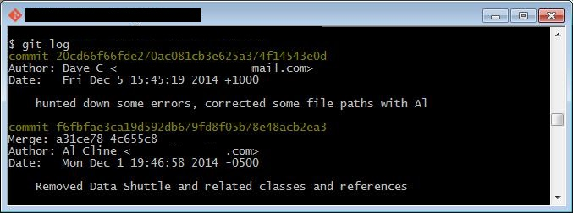
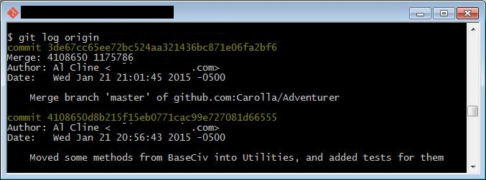
Pulling (to merge in changes):
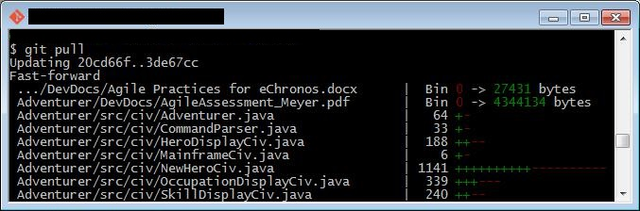
Status after Pull:
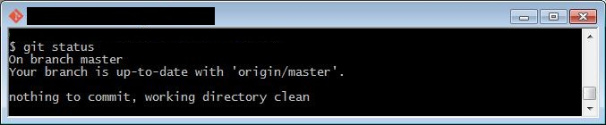

Viewing Commit History
Warning: if there is a colon(:) at the bottom of the bash screen with the cursor then there are more unshown commits. Either keep hitting 'space' to scroll through them all, or hit 'q' to stop viewing commits.
Default: $ git log
$ git log
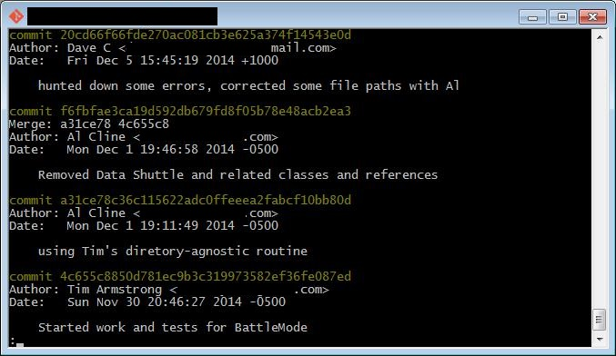
Summarized Change Info: --stat
$ git log --stat
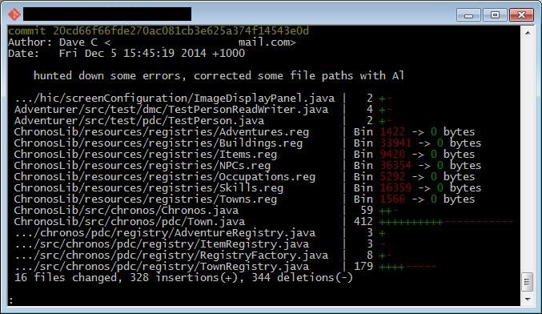
Condensed: --pretty=oneline
$ git log --pretty=oneline
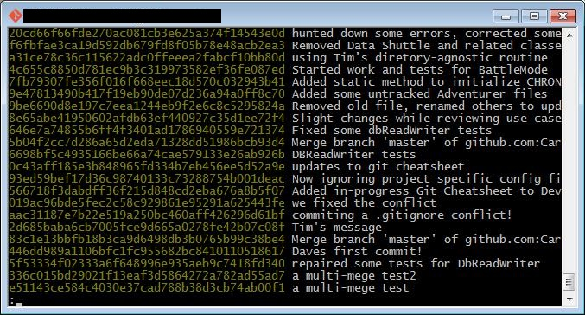
Condensed w/short Hash: --oneline
$ git log --oneline
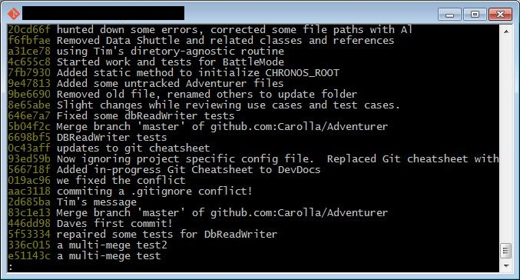
Graphed: --graph
$ git log --graph
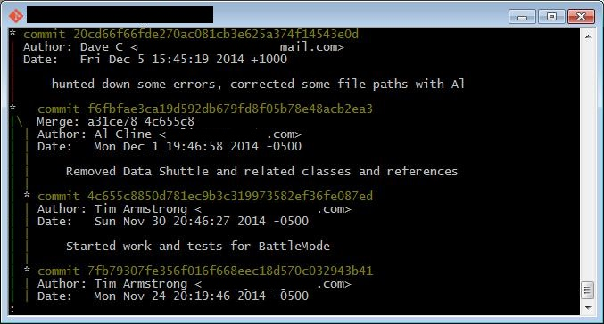
Combined: --oneline –graph
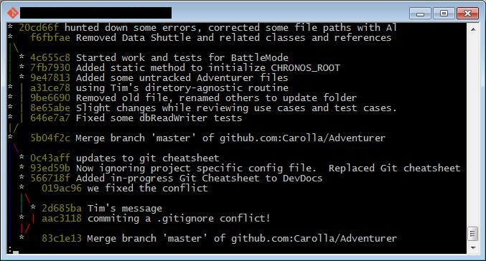
$ git log --oneline --graph

Undoing a Local Change
For a single file:
$ git checkout -- file/to/restore.ext
For all local changes:
$ git reset --hard HEAD
Example:
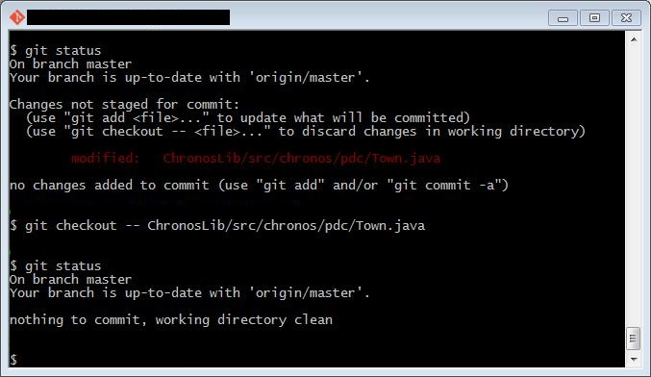
View Remotes
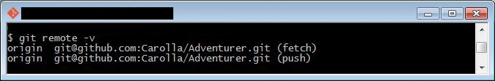
View Branches (including remotes)
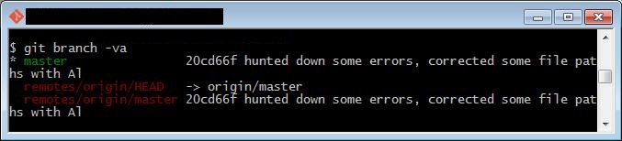

1. Getting the local git setup and cloned from GitHub
2. Committing a file change to the repo, local and to GitHub.
3. Synchronizing the local and remote repos (pulling file changes down to local machine)
4. Merging two files that have conflicts.
5. Refreshing a previously deleting file, that is, restoring a backed up version.

